Asaro (Yam and Plantain Curry)

By Yewande Komolafe
- YIELD4 to 6 servings
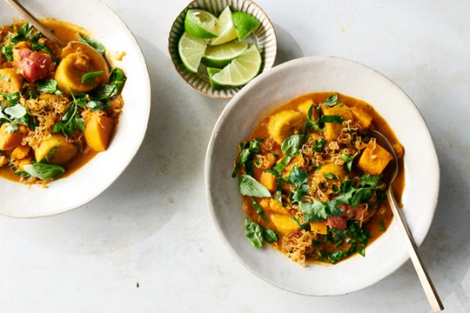

INGREDIENTS
- ¼ cup neutral oil, such as canola or grapeseed
- 4 medium shallots, peeled and thinly sliced (about 1 cup)
- Kosher salt
- 4 garlic cloves, smashed and peeled
- 1 (2- to 3-inch) piece fresh ginger, grated (about 2 tablespoons)
- 2 teaspoons ground turmeric
- 2 tablespoons tomato paste
- 1 whole red habanero or Scotch bonnet chile, pierced all over with a knife
- 1 (14-ounce) can whole peeled tomatoes with their juices
- 1 ½ pounds white or orange yams, peeled and cut into 1 1/2-inch pieces
- 2 green (unripe) plantains (about 1 pound total), peeled and cut into 1 1/2-inch pieces
- 1 (13-ounce) can full-fat coconut milk
- 1 tablespoon red palm oil (optional)
- 4 cups julienned hearty greens, such as dandelion greens, collards or lacinato kale, tough stems removed
- ¼ cup fresh basil leaves, torn
- ¼ cup fresh cilantro leaves and tender stems
- 1 lime, sliced into wedges for squeezing

PREPARATION
- Heat a medium pot, large saucepan or Dutch oven over medium. Pour in the neutral oil, add the sliced shallots and cook, stirring frequently, until shallots are caramelized and golden brown, about 5 minutes. Remove shallots from the oil and allow to drain on paper towels or a cooling rack. Season with salt and set aside.
- Drain all but 2 tablespoons of the cooking oil out of the pot. (Reserve extra oil for another use.) Over medium-low heat, add the garlic, ginger and turmeric to the pot and sauté until softened and fragrant, about 2 minutes. Add the tomato paste and cook, stirring constantly, for an additional 2 minutes or until it begins to stick to the bottom of the pot.
- Drop in the chile and add the whole peeled tomatoes with their juices, crushing the whole tomatoes with your hands as they go in. Stir to combine ingredients and dissolve the tomato paste, then add 3 cups water and bring to a boil over high heat.
- Once boiling, season with salt, reduce heat to medium, add the yams and simmer until the yams are just beginning to soften, about 10 minutes. Add the plantains and cook until both are tender but hold their shape, and the liquid is slightly reduced and thickened, 15 to 18 minutes.
- Stir in the coconut milk and red palm oil, if using, season with more salt and let simmer for another 10 minutes. Add the greens and cook until tender, 2 to 3 minutes.
- To serve, remove and discard the cooked chile. Ladle the curry into bowls, top with the caramelized shallots, a scattering of basil and cilantro, and several squeezes of lime juice.

