Elaine’s Fettuccine Alfredo

ALEX WITCHEL
- YIELD6 servings
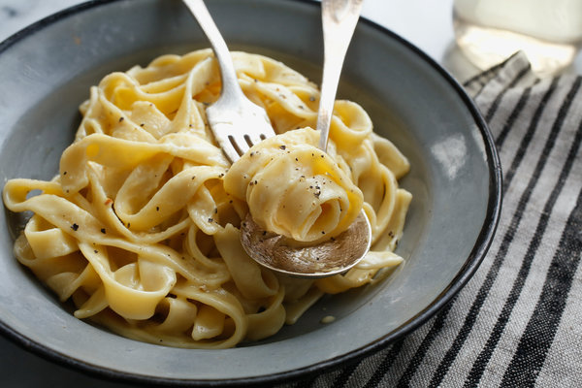
Craig Lee for The New York Times
This recipe came to The Times in a 2004 article about Elaine Kaufman, the founder and proprietress of the famed New York restaurant and celebrity hot spot that bore her name and where this dish was served. There is nothing fancy or complicated about it – it's glorified macaroni and cheese, really – but it is delicious and deeply satisfying. (Fun fact: Jackie O was a fan.)
Featured in: The Salon Keeper.

INGREDIENTS
- Salt
- 2 tablespoons butter
- 1 small clove garlic, finely chopped
- 1 ½ cups heavy cream
- 1 large egg yolk
- 1 pound fresh fettuccine
- 1 cup freshly grated Parmigiano-Reggiano cheese
- Freshly ground pepper to taste

PREPARATION
- Bring 6 quarts generously salted water to a boil.
- While the water heats, melt the butter in a large, deep skillet over medium-high heat. Add garlic; saute until fragrant and sizzling, about 2 minutes. Whisk the cream with the egg yolk in a bowl until blended; pour into the garlic butter. Reduce heat to medium-low; stir until hot but not boiling. Keep warm over low heat.
- Meanwhile, cook the pasta, partially covered, until al dente. (The pasta will float when it's done.) Drain in a colander, shaking out excess water, but reserve a little cooking water. Pour hot pasta into the cream mixture and toss to coat (still over low heat). Add the cheese and keep tossing gently until cream is mostly absorbed. Season with salt and pepper. If sauce is absorbed too much, toss with a little pasta water. Serve in warm bowls.

